# Guidelines for Visual Code (VS Code) Installation and Setup

## Step 1: Download the installation files from the Internet

Start the browser of your PC and the latest version of VS Code software that is to be installed is searched.

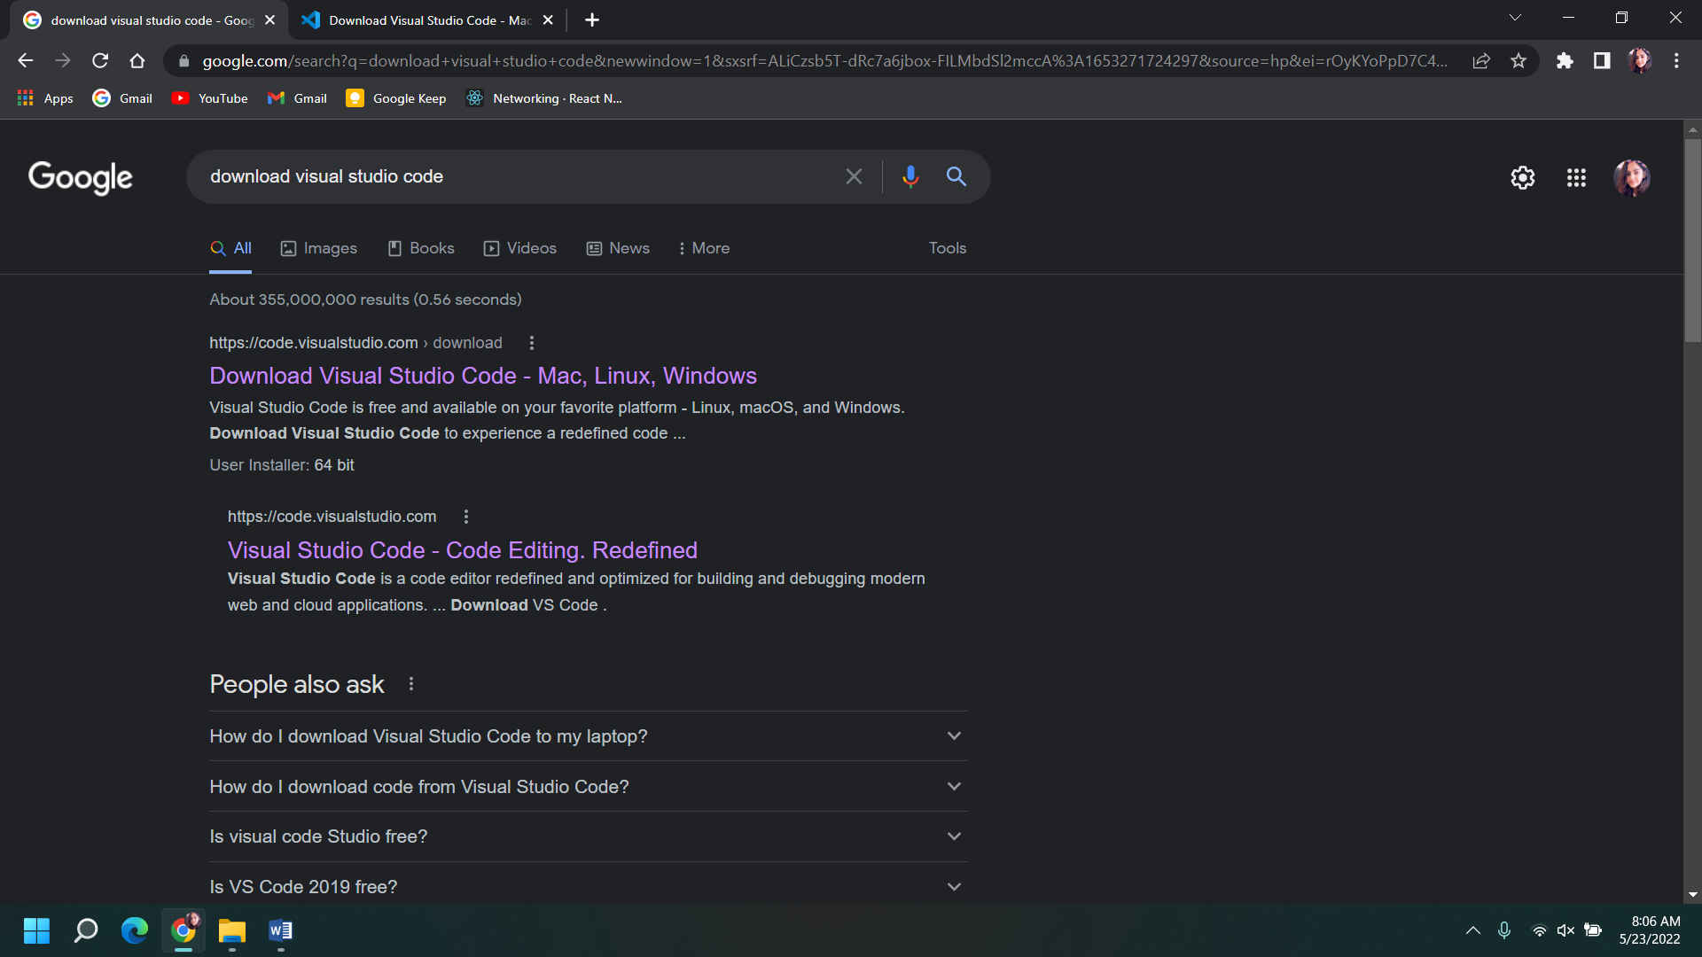

The software that is selected is done using the OS version of your device.

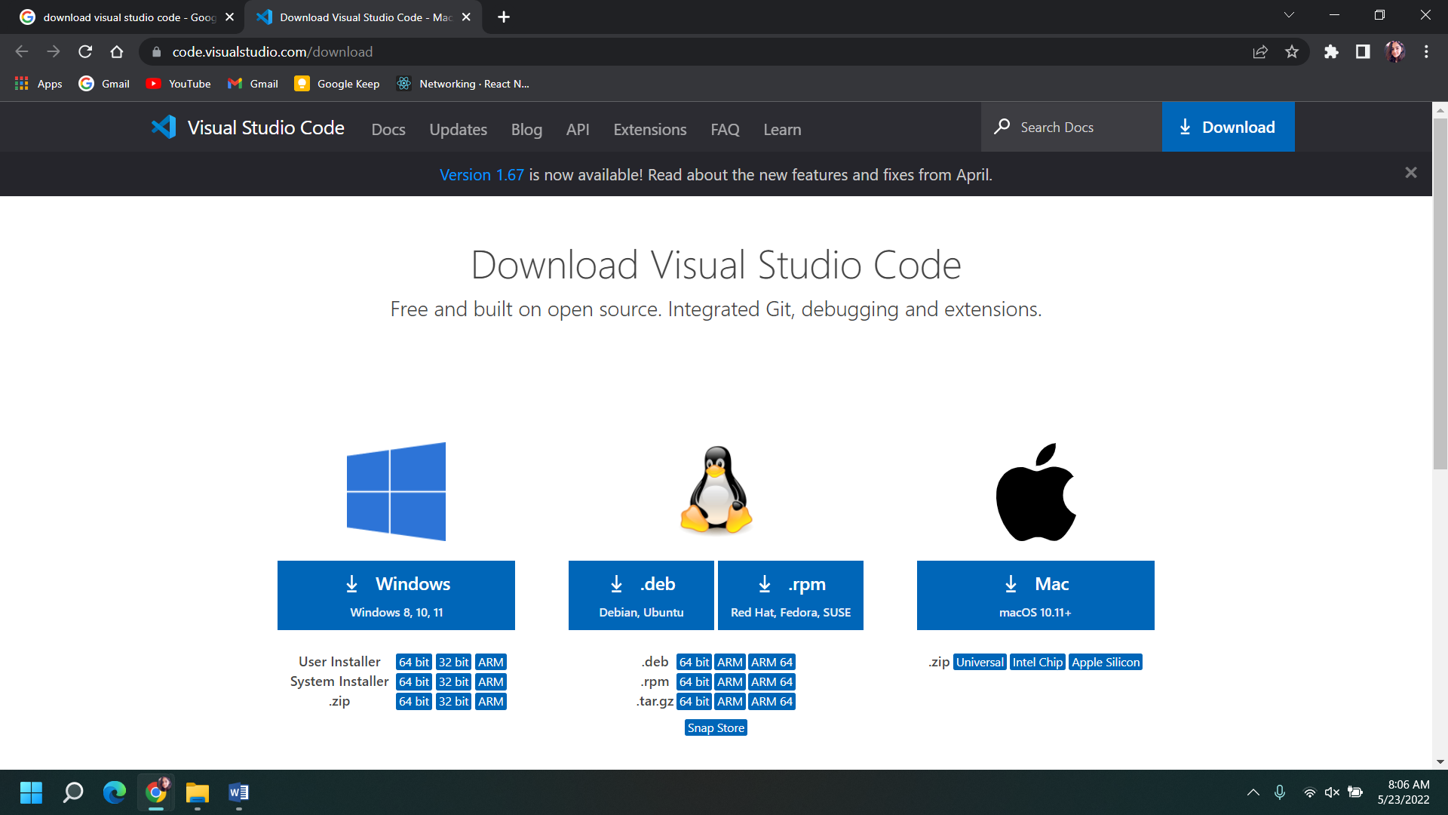

## Step 2: Start the setup wizard

After you continue with the setup, there is an appearance of the set up wizard dialog box, where you click on the checkbox agreeing to the terms and conditions and click ‘Next’ to configure further installation process.

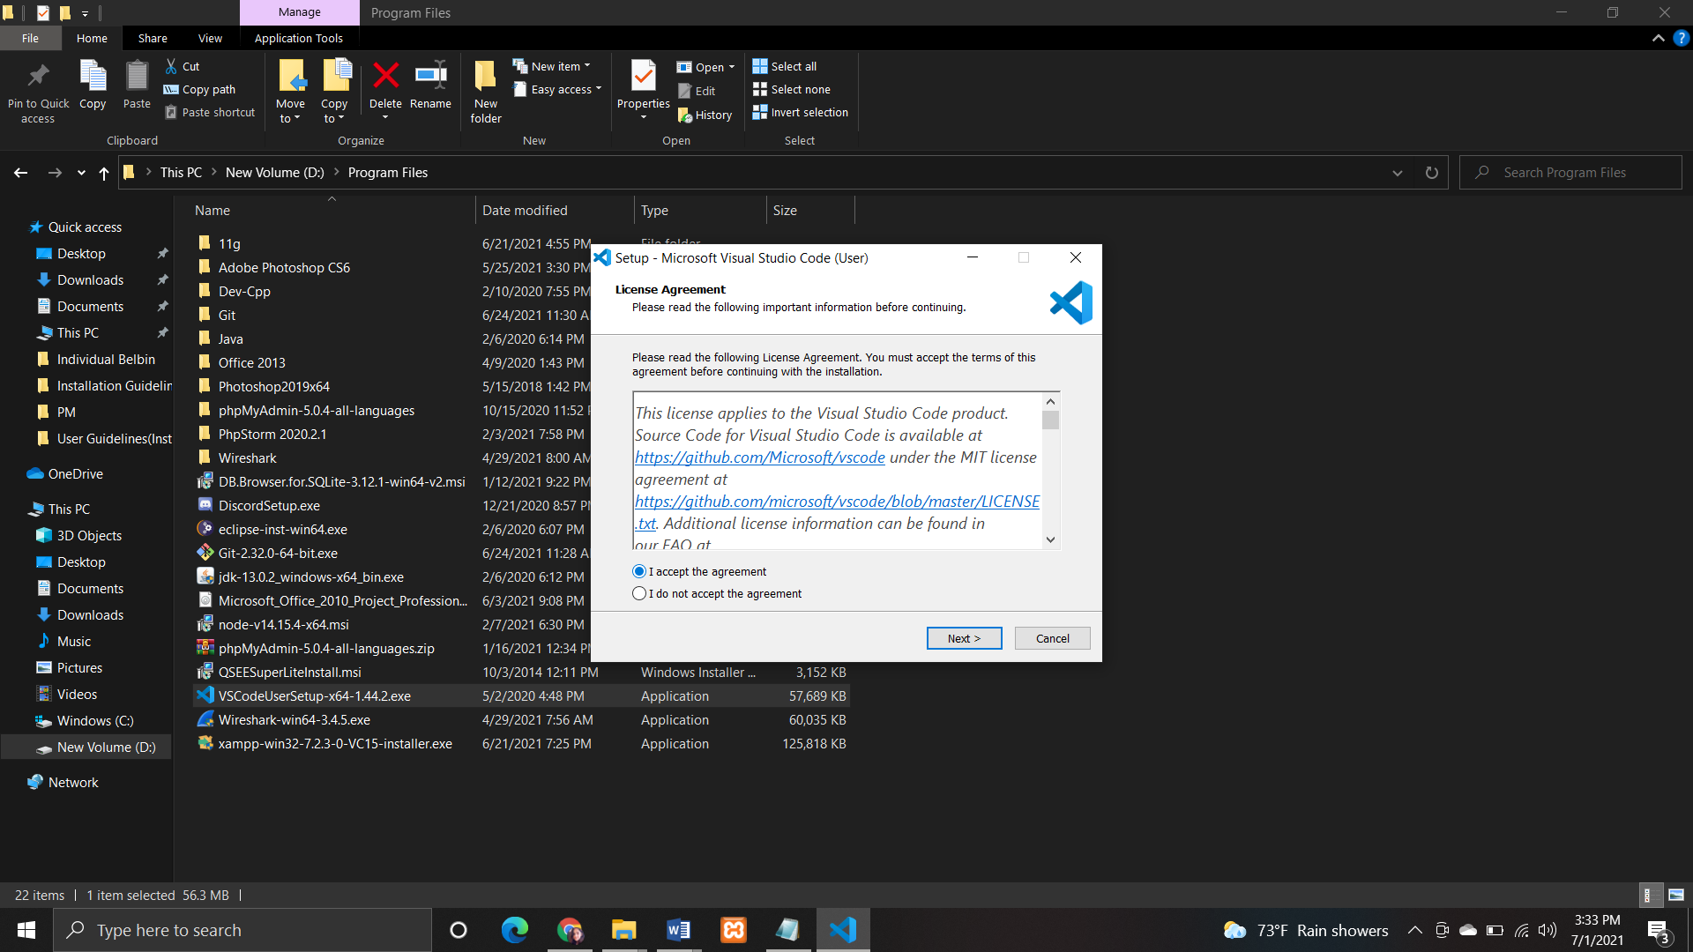

## Step 3: Choose the installation directory

Now, the directory for the downloaded software to be stored in is selected.

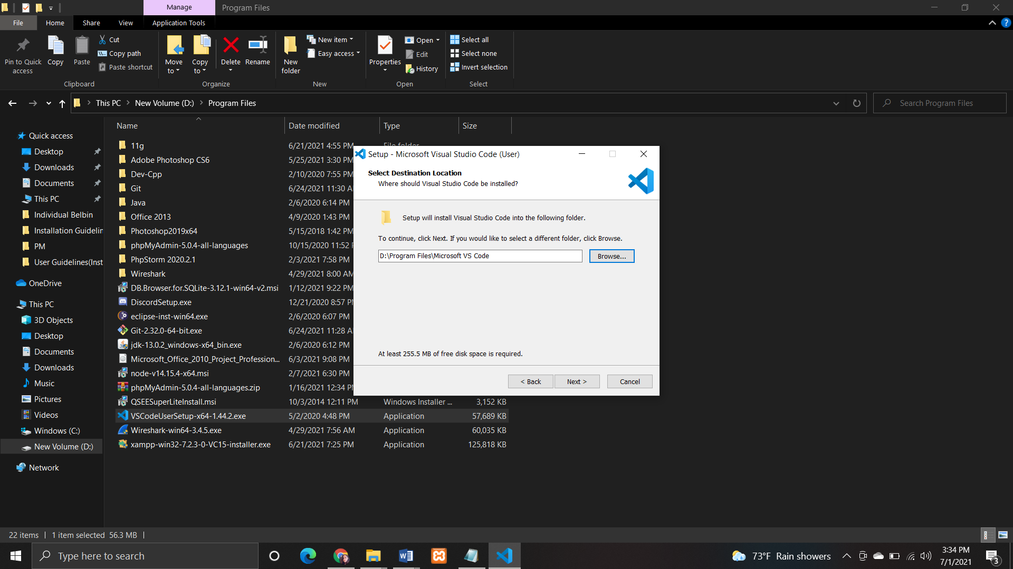

## Step 4: Choose the tasks performed during installation

After clicking on the ‘Next’ button, select the extra tasks to be done while the software is being installed. These extra tasks are created for the flexibility of user while using VS Code.

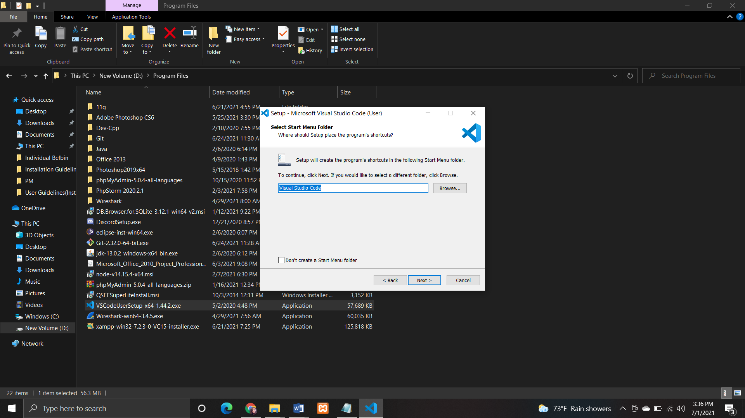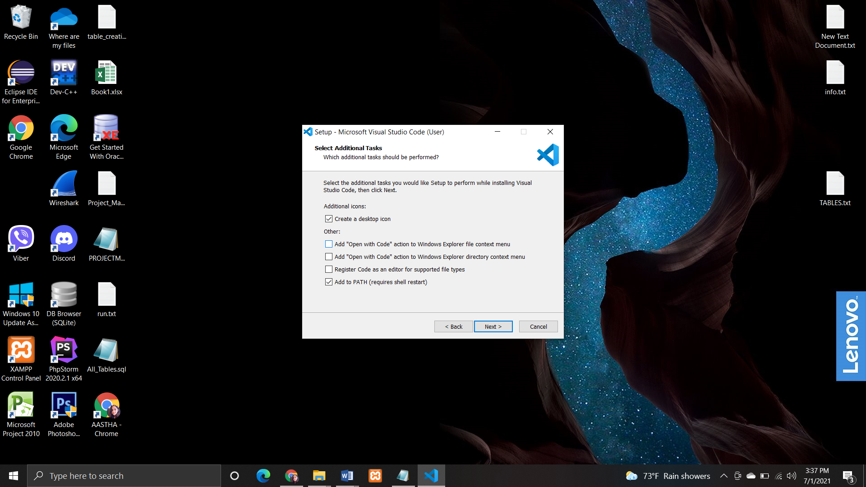

## Step 5: Start installation process

Then click the ‘Install’ button on the setup pop-up screen and the installation process will commence. This may take a few minutes for the software to be installed.

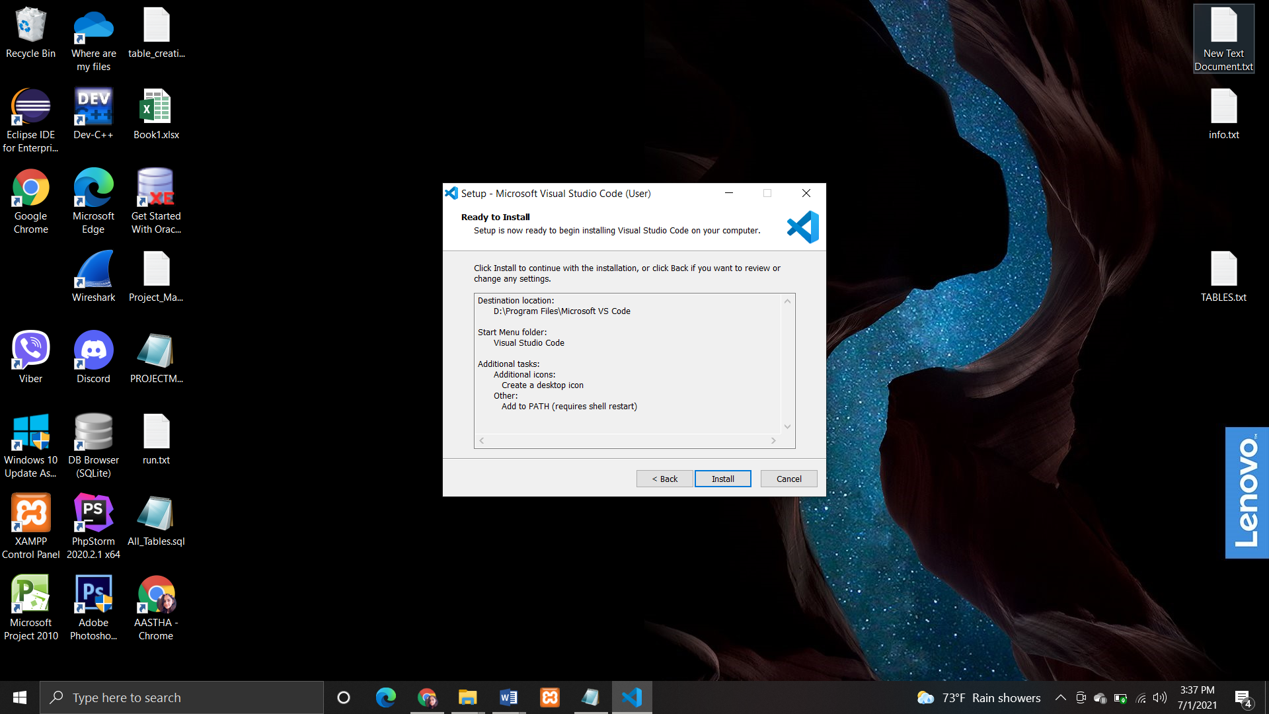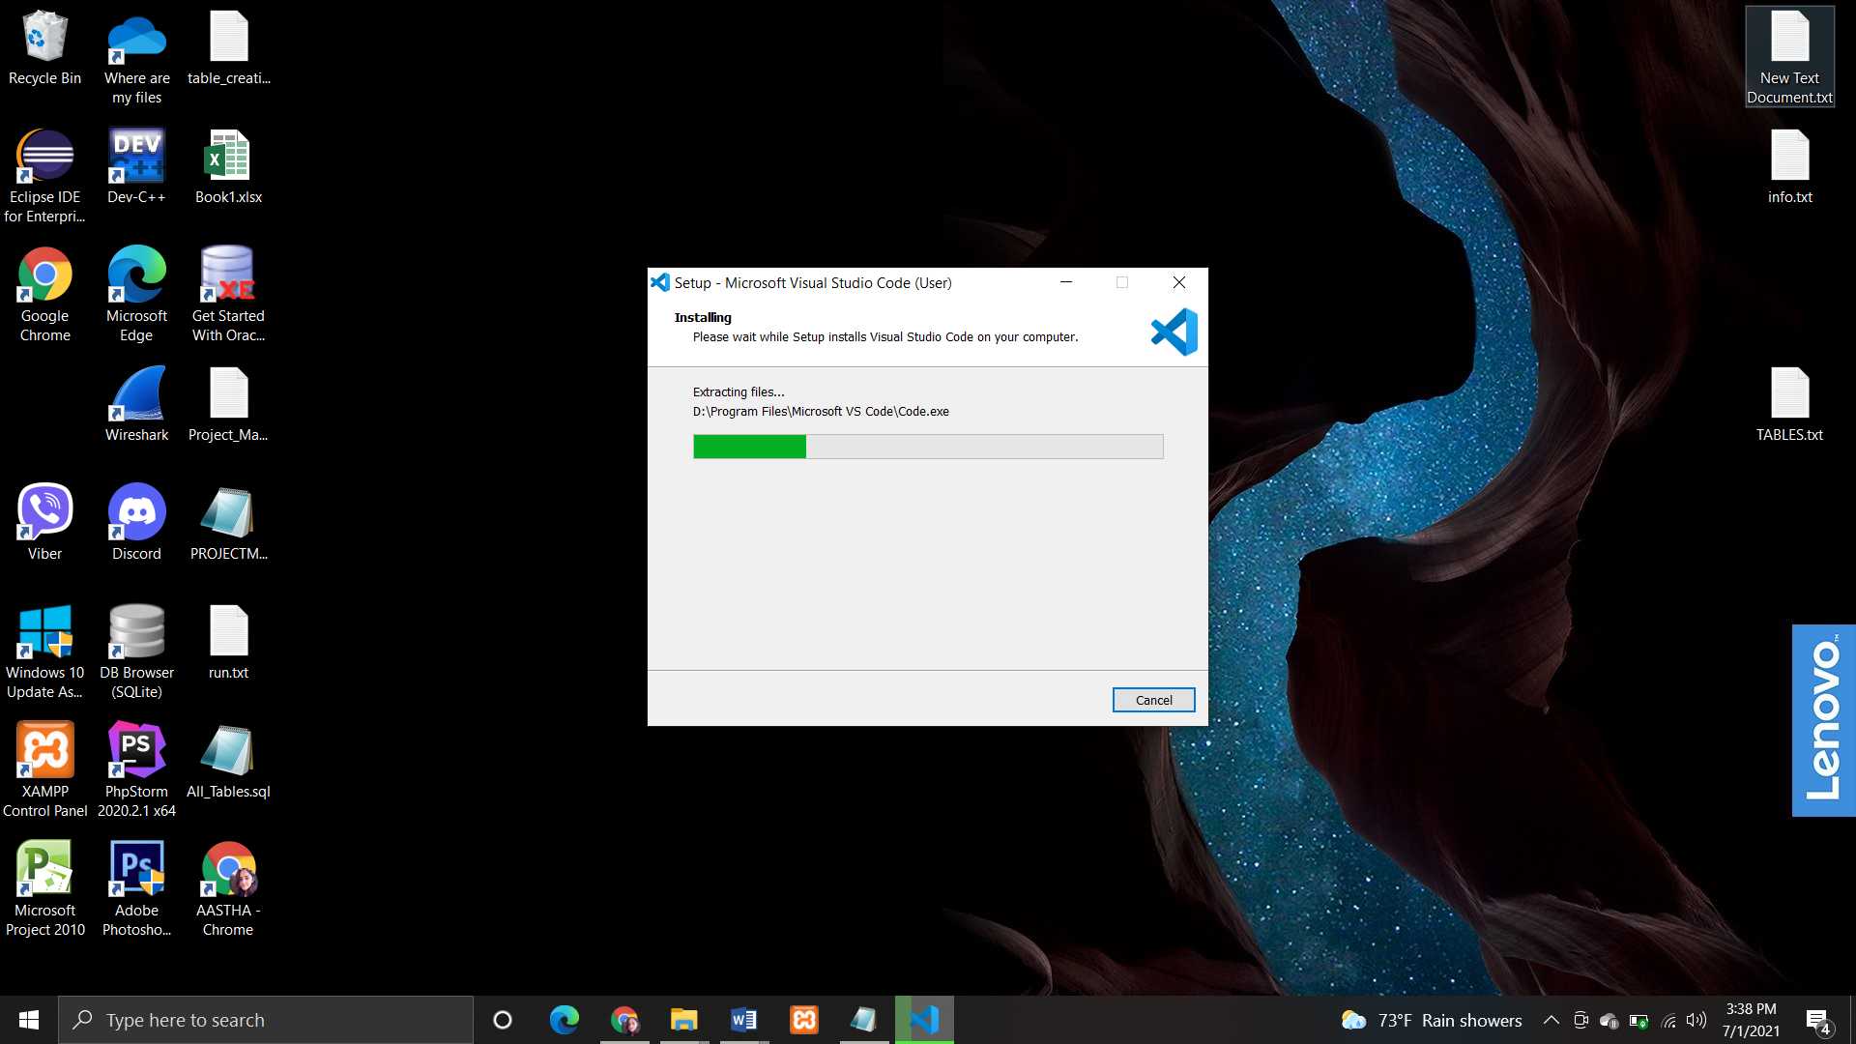

## Step 6: Complete Installation

After the software has been installed, a dialog box is displayed that specifies the user about the completion of installation process. When the ‘Finish’ button is clicked then the process will end. VS Code is now ready to be used.

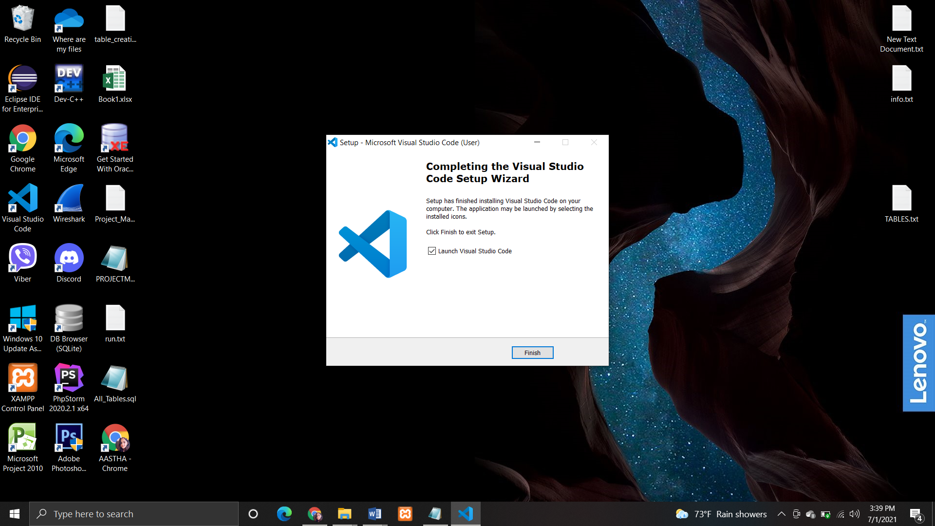

### The Working Area of VS CODE

